**GERMAN CREDIT DATASET ANALYSIS**

1. Attributes Names and their types:

* Credit_history – Nominal
* Purpose – Nominal
* Serving_status – Nominal
* Employment – Nominal
* Personal_status – Nominal
* Other_parties – Nominal
* Property_magnitude – Nominal
* Housing – Nominal
* Job – Nominal
* Other_payment_plans – Nominal
* Checking_status – Nominal
* Own_telephone – Nominal
* Foreign_worker – Nominal
* Class – Nominal
* Credit_amount – Numeric
* Istallment_commitment – Numeric
* Residence_since – Numeric
* Age – Numeric
* Duration – Numeric
* Exizting_credits – Numeric
* Num_dependents – Numeric

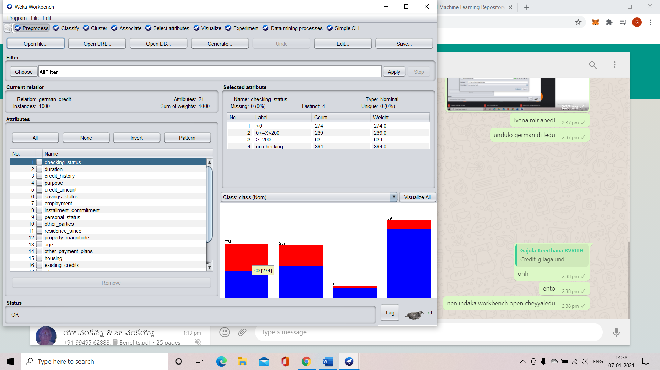 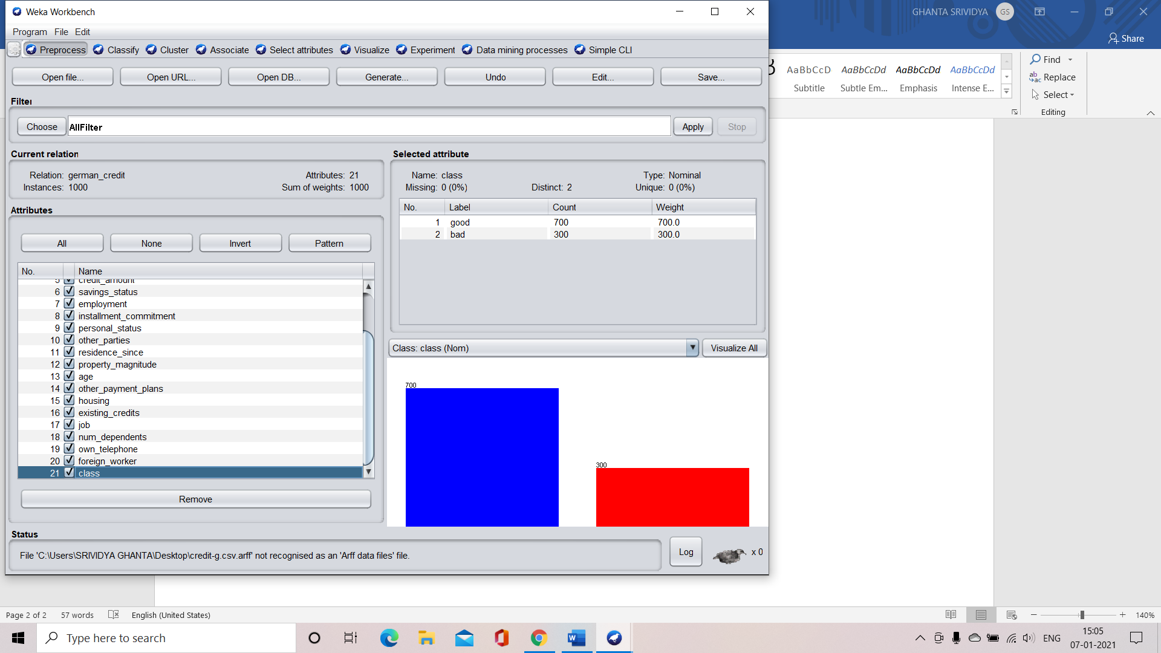

2.Number of records in the dataset are 1000

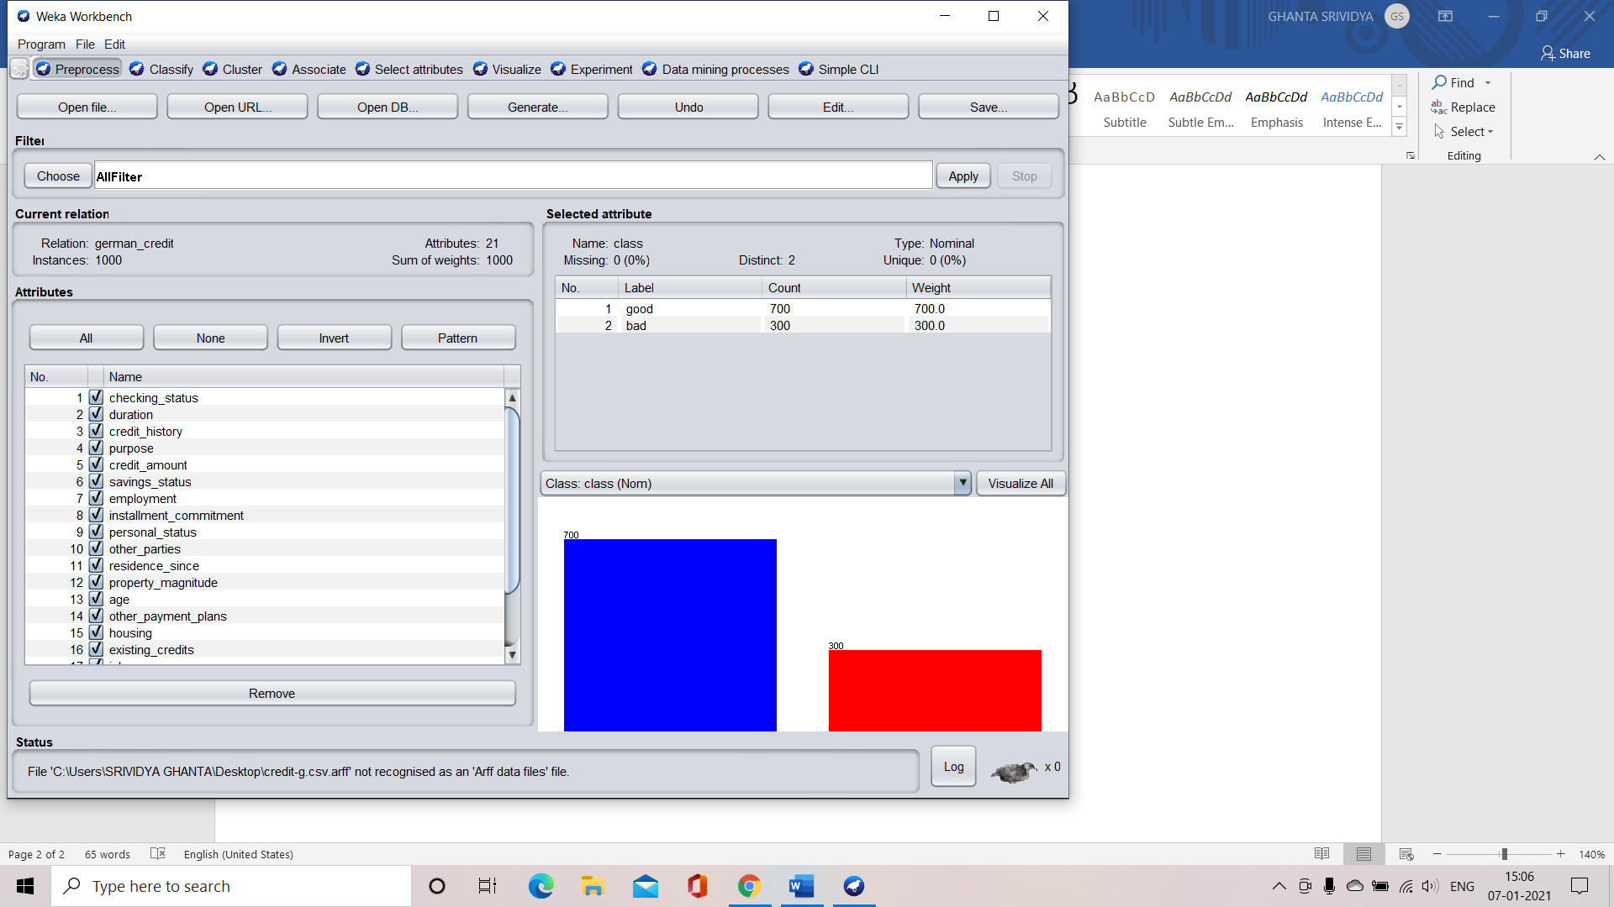

3.Class attribute in the dataset is class

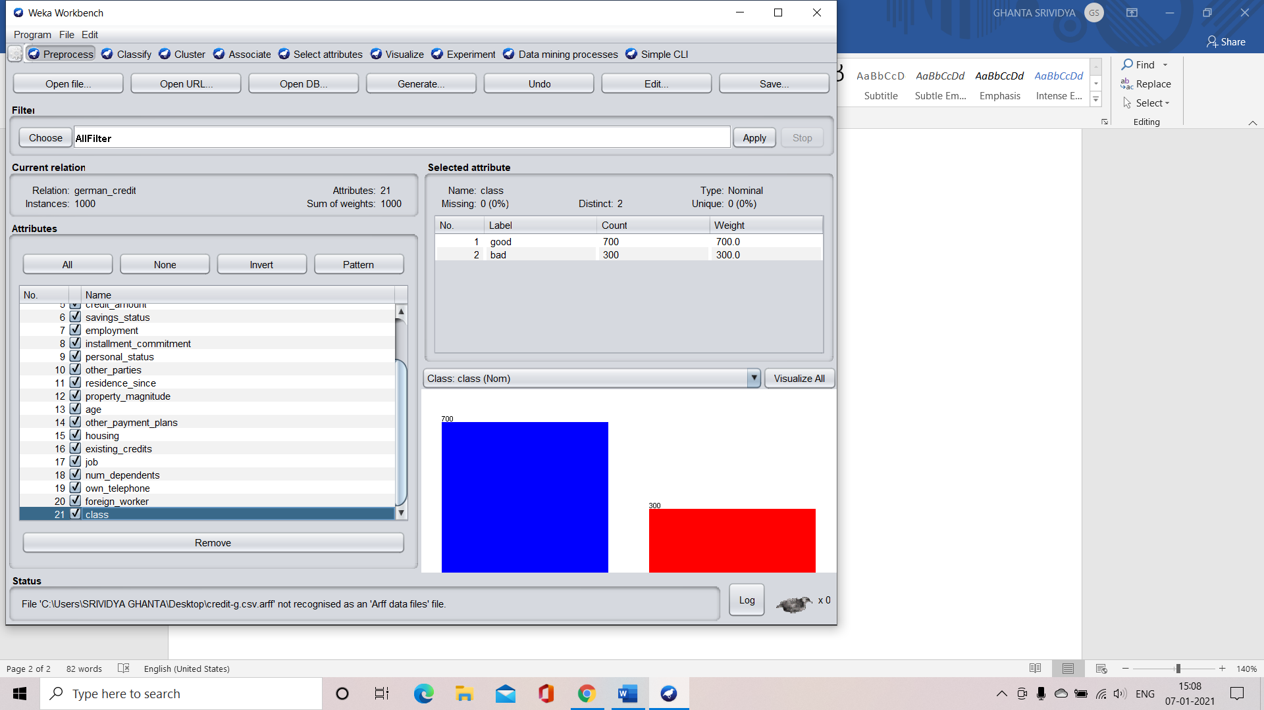

4.Histogram

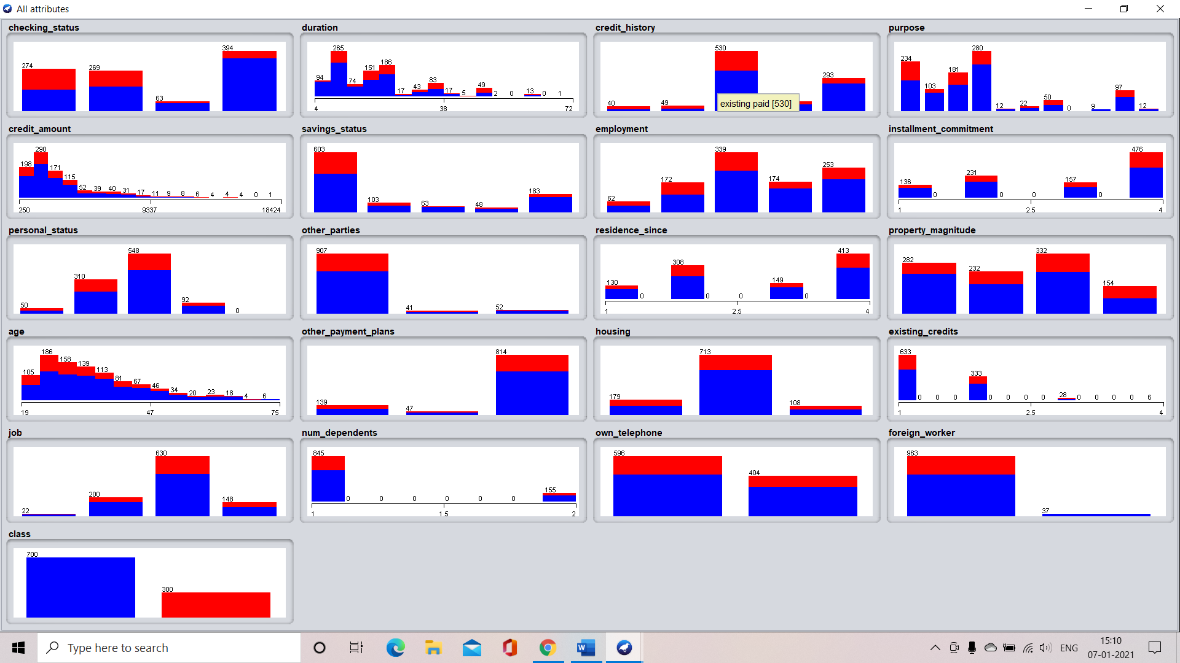

5.Number of records for class are

Good – 700 records

Bad – 300 records



IRIS DATA SET ANALYSIS

1.Attributes Names and their types:

* Sepalwidth – Numeric
* Sepallength – Numeric
* Petallength – Numeric
* Petalwidth – Numeric
* Class – Nominal

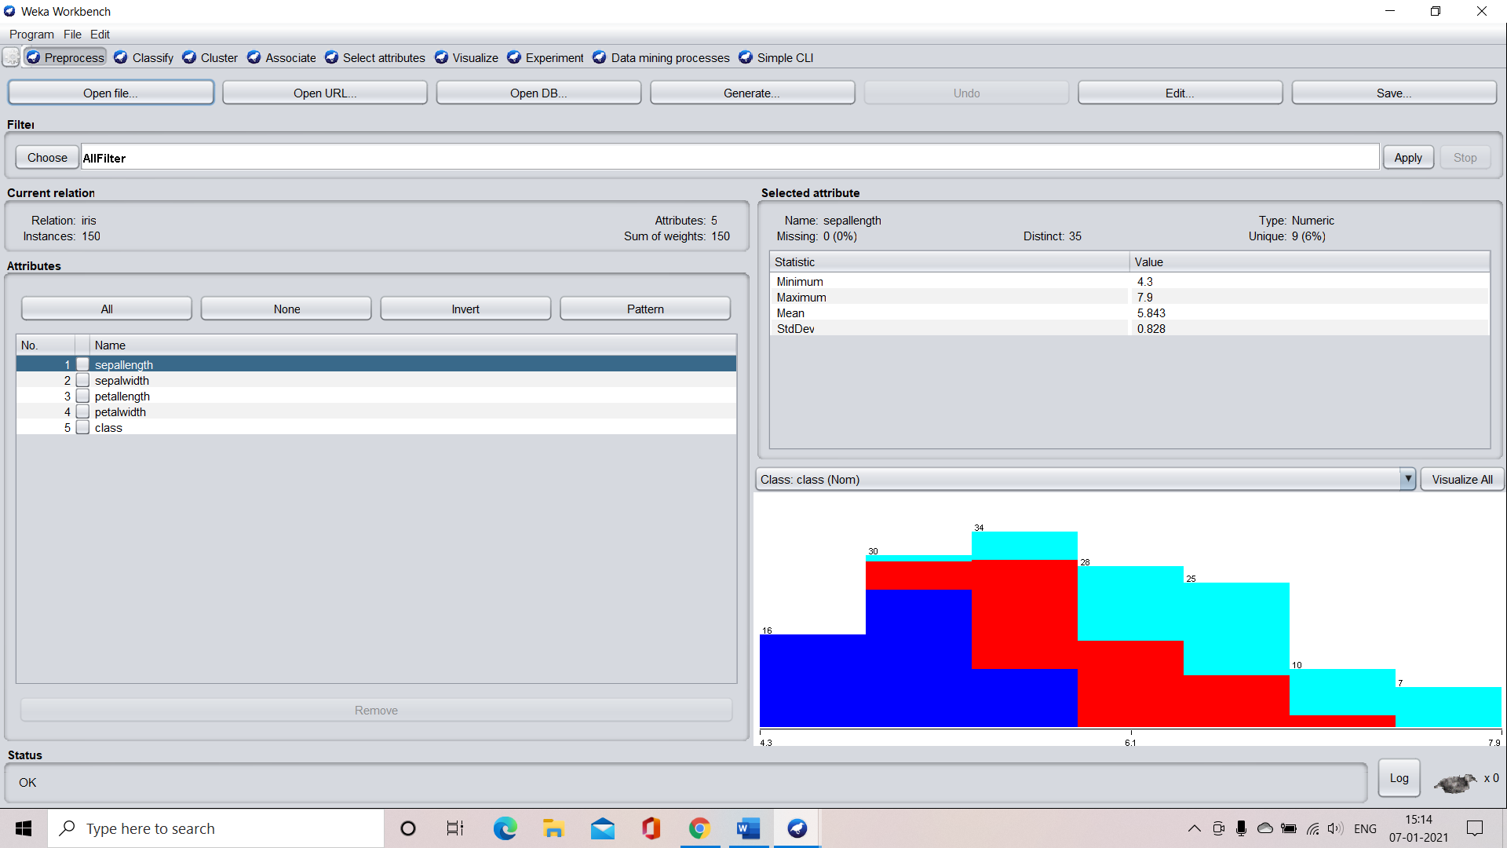

2.Number of records in the dataset are 150



3.Class attribute in the dataset is class

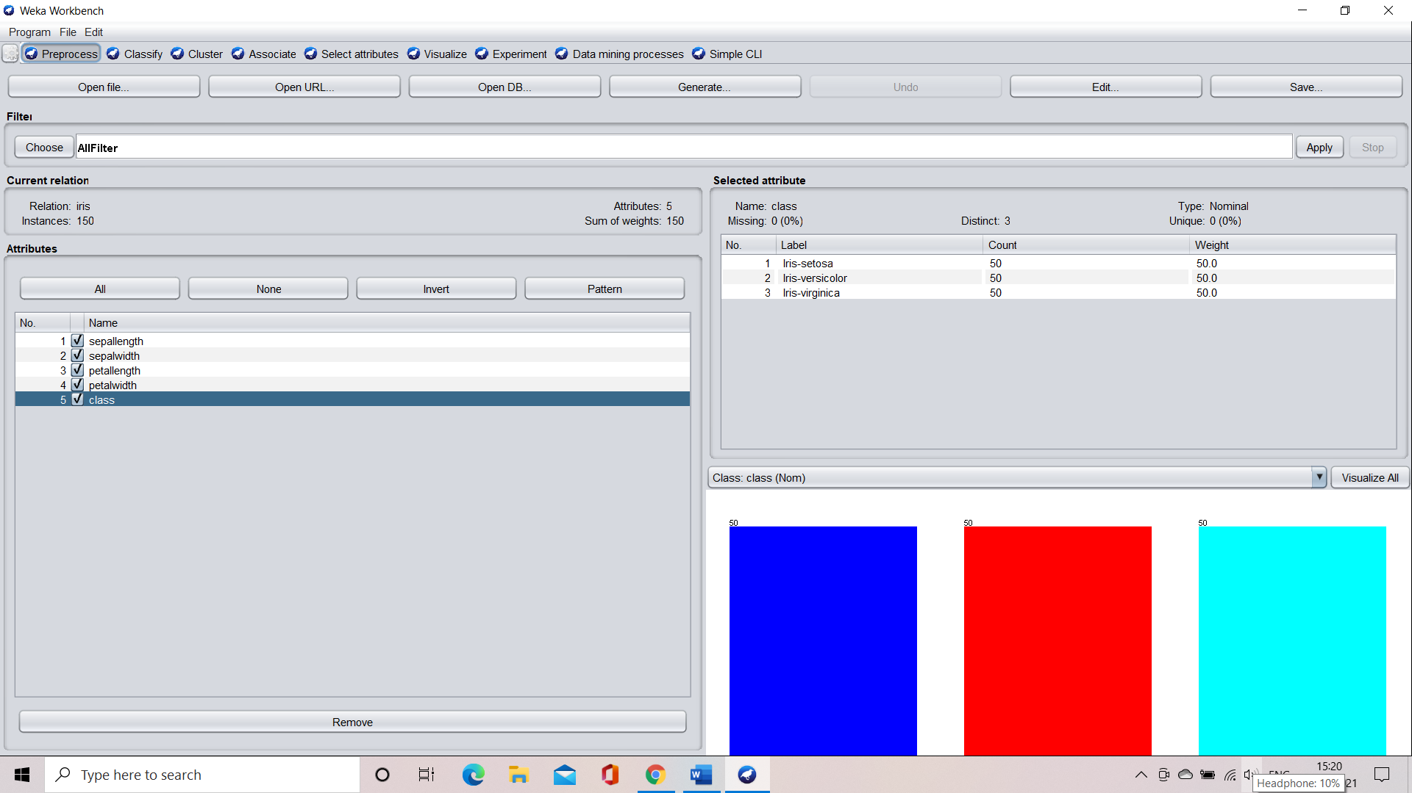

4.Histogram

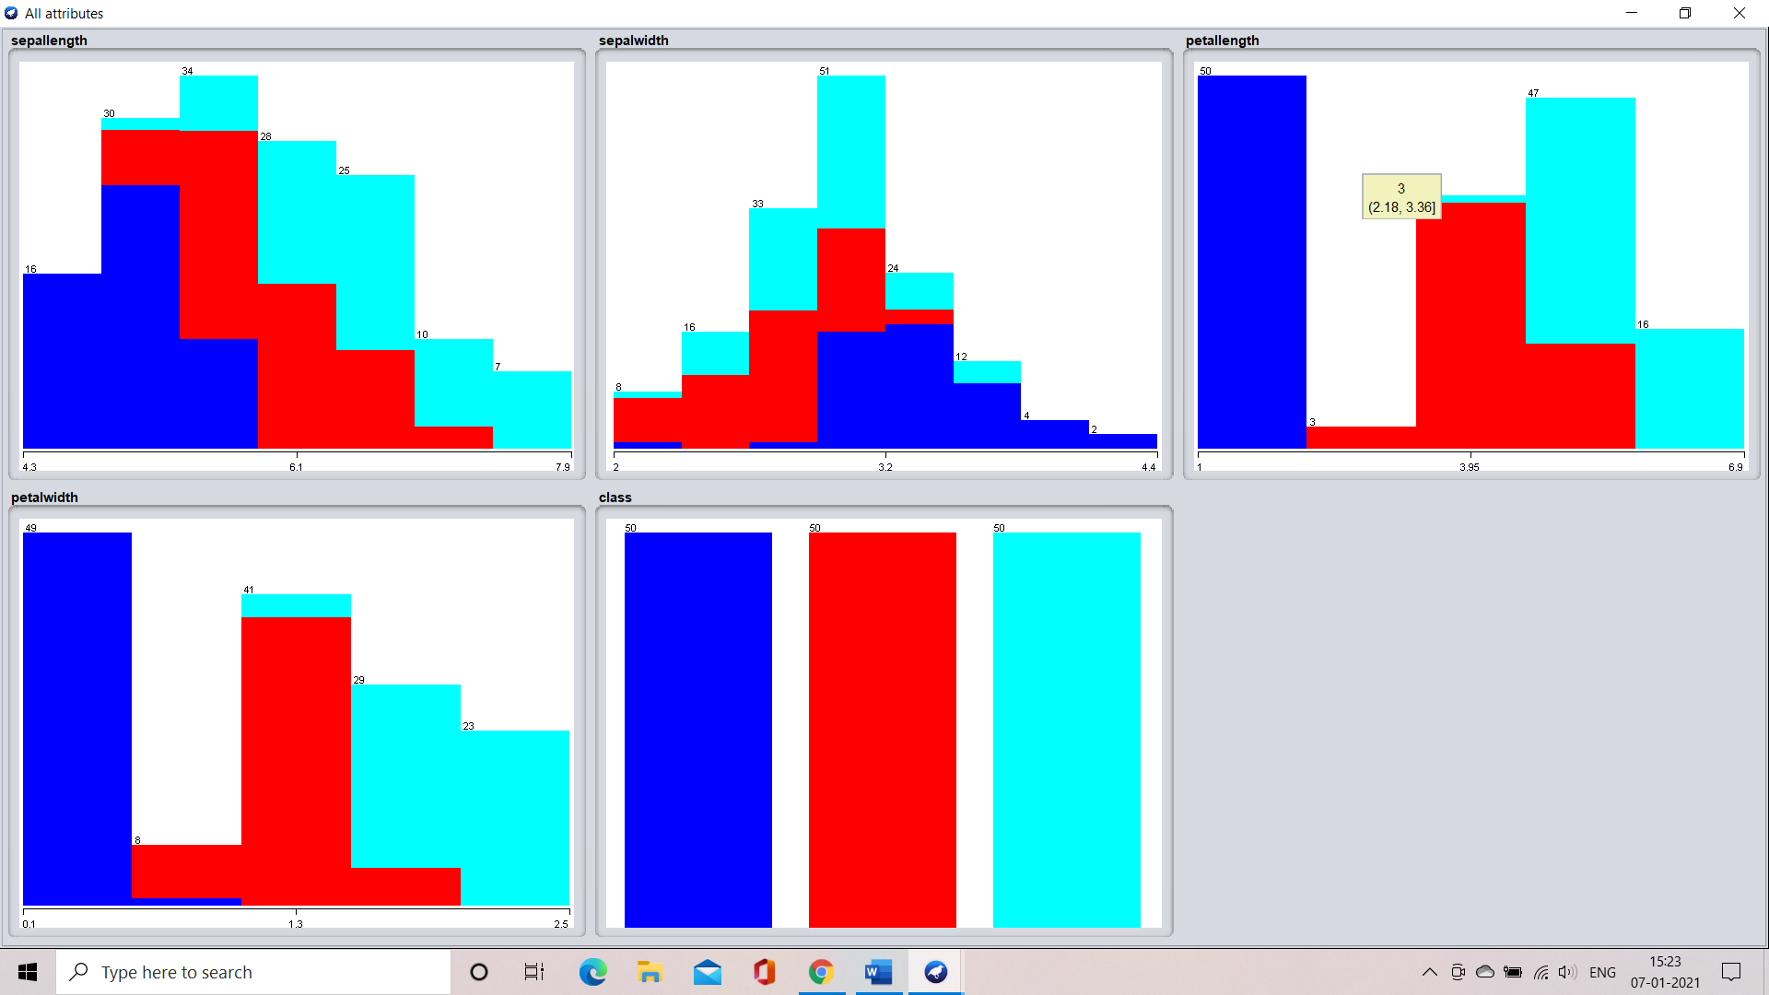

5.Number of records for each class:

Iris-setosa – 50

Iris-verginica – 50

Iris-versicolor – 50

